**Short Horror**

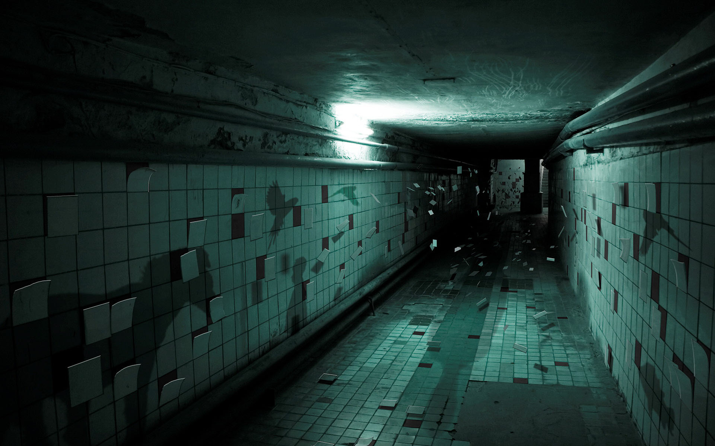

**Design Document**

**By Joel Draper for MansionGaming**

Contents

**Synopsis** 3

**Introduction** 3

**Art** 3

**Assets** 7

**Audio** 8

**Characters** 8

**Controls** 10

**Gameplay** 10

**Start Up** 11

**End Goal** 11

**Level Design** 11

**Plot** 11

**Setting** 12

**Target Platform** 12

**User Interface Design** 12

# **Synopsis**

Ever since you were a little boy, you’ve always wanted to live in a forest, and when a small log cabin in the middle of the woods comes on the market, you jumped at the opportunity. Only…somethings not quite right. Just outside of this sleepy towns in the misty peaks of Washington State, somethings been hiding. Something which wishes not to be revealed…

# **Introduction**

In this short Horror Game, you play as a young adult who has always dreamed of living out in the wilderness. In this mixture of Amnesia and Gone home, you have to find out the houses dark secret. Exploring the evidence left in the house, you have to find out what is in the house with you, and the best way to avoid it.

The game bases itself more on the atmosphere and the player’s personal discovery, with the story taking a few hours at most to complete. The game will contain a mixture of jump scares and typical horror sequences, as well as notes and various artefacts that tell the story of the game.

The game is linear in terms of story, as there is one story and one ending, however how much about that story the player finds out is up to them through their interaction with the game world through audio diaries and written documentation such as newspaper clippings, letters and diary extracts.

The game is played from a first person experience, helping to immerse the player with the story. The player can control the person who they are playing with, helping discover the backstory.

# **Art**

The game will not have a unique or defining art style, instead with a more real life artistic style, however due to the complexity of this within a short amount of time, the graphics do not matter to the concept of this game, rather the story and the atmosphere of the game.



Figure 1 - Washington State, the setting of the game

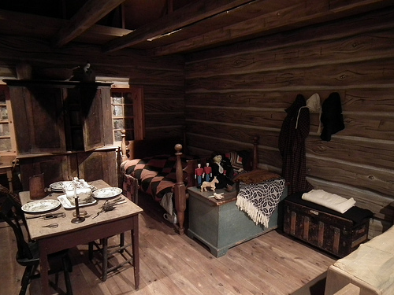

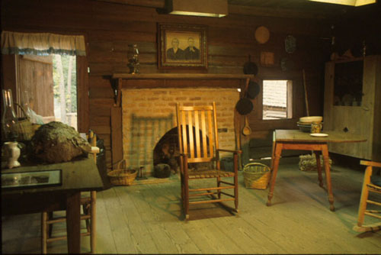

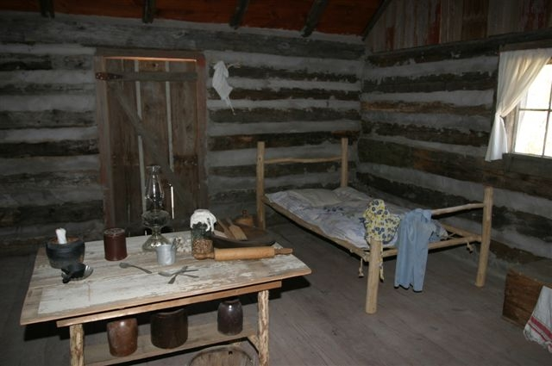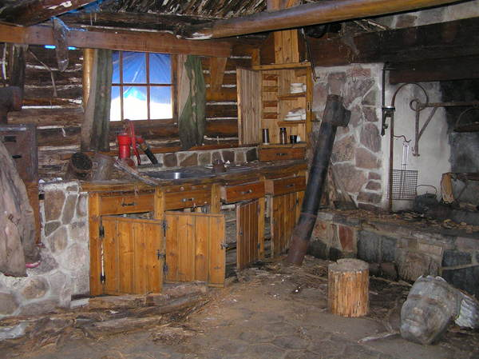Figure 2 - Old cabin interiors

# **Assets**

**Audio**

* Door unlocking SFX
* Door opening SFX
* Footsteps
* Heavy breathing
* Paper interaction
* Answering Machine Play Button
* Answering Machine Narrator (“You have 1 new message”, “to play the message again”)
* Answering Machine Beep
* Answering Machine Messages (The man’s voice)
* Static
* Scream
* Scratching
* Wind
* Tension Building Music
* Credits Music
* Torch Turning On OR Lamp being lit

**Characters**

* Monster (animated)

**Environmental**

* Television
* Answering Machine
* Knife
* Killers Hood

**Weapons**

* Torch OR Tilly Lamp
* Batteries OR Oil

*Other objects you would find in a cabin (bed, cups, tables, stove, etc.)*

# **Audio**

The game will contain typical horror audio design. The music will be non-diegetic and will have a lot of strings, and an unnerving feel to it. While the sound effects will include stereotypical horror diegetic sound such as footsteps, doors opening, locks unlocking, et cetera that correspond to the object. They will play along with the non-diegetic sound and various objects that are interactive to add that unnerving atmosphere. As well as some depressing music, maybe for the end or for other parts that require music that invokes that kind of “sad” emotion into the player.

Example Music:

Nightmare on Elm Street - Theme Song: <https://www.youtube.com/watch?v=xanCvQysRgc>

The happening - End title sweet: <https://www.youtube.com/watch?v=RGKMccOHIEc>

Halloween Theme Song: <https://www.youtube.com/watch?v=iP-jYiuDD9g>

Uncharted: Drakes Fortune – Unwelcome Guests <https://www.youtube.com/watch?v=7IT9SiPStPY>

Silent Hill 2 – Pyramid Head <https://www.youtube.com/watch?v=cn144yWiZF4>

# **Characters**

There are two characters within story that the player can witness, plus many that are mentioned within interactive objects.

The **Player** plays as an unnamed, middle aged who has always dreamt of owning a house away from civilization. Moving in to the house where the game takes place, not much is known about the characters back story other than that. They know nothing of the house they brought, only that it’s the house they’ve always wanted. They find out more about the house through the players actions.

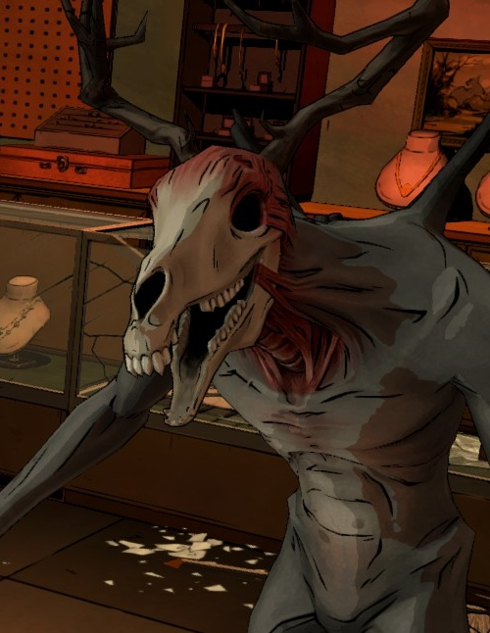

Figure 2 - The monster is based on the Jersey Devil

The **Monster** is a terrifying supernatural creature that is very deadly, yet rarely appears. They are the previous owner of the house, and are not happy about it being occupied by someone other than themselves. They are only encountered in jump scares and sequences where the player has to hide from them. They give the sense that they are significantly stronger then the player, however cannot kill the player.

There are also a load of side characters that can be found by interacting with the environment.

A **condemned witch** who lived in the house, but was executed, however she left a curse on the house before she died.

An **Old man** who lived in the house in the 1880’s but died of fright, and left numerous notes detailing of things he allegedly saw in the house.

A **man’s voice** who left creepy, threatening voice mails on the houses answering machine.

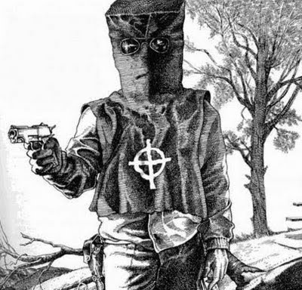

Figure 3 - The zodiac killer, the basis of the serial killer whose notes, plans and equipment can be found within the house.

A **serial killer** from the 1960’s who used the house as their hideout where they planned the crimes and used it to escape detection.

# **Controls**

The game will use one of the most commonly used control schemes for this genre of first person game.

**W** is used **to move the character forward**, **S to move the character back**, **A to move the character to the left** and **D to move the character to the right**.

The player **looks around with** the **mouse movement** function, and **interacts with** the objects in the environment with **E**.

The **main menus are interacted with by mouse clicks and mouse movement**.

# **Gameplay**

Gameplay in this game revolves around two core features: Discovery and Vulnerability.

The discovery aspect of the game revolves around discovering the history of the house and its former residents. This helps the player feel immersed as they maintain the same “uneducated” aspect of the character they are playing as. They also feel the same sense of vulnerability as the player character, due to their only knowledge being what’s written down or said in quite horrifying “notes.”

The vulnerability relies on jump scares and atmosphere to make the player feel frightened. This will be done through music, sound effects, jump scares and terrifying interactive features that make the player realise what is going on, and feel vulnerable and alone. This would make the player feel terrified, which is the aspect we would want them to get from this horror game.

The game has no cut scenes, all interactions and story elements are playable by the player.

## **Start Up**

The player starts inside the house, just after they have opened the door. The screen is black. The first sound they hear is the door unlocking and opening. Then fade in. The player is then free to do whatever they deem fit.

## **End Goal**

The player is free to leave whenever they want, however once they leave there is no going back. Once they leave the screen fades to black as the door unlocks then closes once more, the end credits then play detailing who made the game and what it was called.

# **Level Design**

Level Design in this game will be simplistic. The game is set in a small cabin in the woods so there would need to be a bedding area, kitchen area and resting space to help make the cabin feel like it was designed to be the players home. There should also be some more modern aspects for jump scares and interactivity such as an answering machine and a television set (any era, just with the possibility of static) However it would also need to be dark and uneasy as it is a horror game, and the player would need to feel immersed in the terrifying situation in front of them and to immerse them in the atmosphere.

So there would need to low level lighting, it should be set at night so that no light comes from the windows, but rather from flickering oil lamps and generator powered electric lamps and static from the television.

Littered around the house should be notes which the player can read to learn more about the back story and get more immersed in the world of the story, while the answering machine should be interactive for the disturbing answer phone messages.

# **Plot**

In the colonial era, an old woman lived in the house. However she was condemned by the local witch as a heretic, and was executed as a witch. However before she died, she put a curse on the house so that anyone who lived there could suffer as much as she did.

In the 1880’s an old man lived in the house. However he saw many unexplained ghostly, paranormal phenomena and documented his experiences. However one experience must have been too much for him, as he did from frighten.

In the 1960’s a mysterious serial killer used the building as a hideout. It was from here in which he planned his murders and hid from the police. However he couldn’t stay hidden for long and his hideout was revealed but the police messed up the operation and he managed to escape. Except he didn’t have time to cover his tracks, and left all his planning documentation for the murders and his equipment behind.

Skip forward to current day, the player character has brought his dream cabin in the middle of nowhere. *This is where the game begins.* The player takes on the role of the player character and uncovers the dark secret about his dream house. There is a paranormal, supernatural figure residing in the house and also about its dark past. There are many scribbled notes and audio documents of people who has previously resided in or visited the house and the player must use them to uncover the truth.

# **Setting**

The game is set in a cabin in the woods of Washington State. It is quite an old and small cabin, with room for 3 to live in at most. The cabin should have a living area with a dining table and TV, a bedroom area with a bedside table and wardrobe and a kitchen area with a stove and answering machine.

The house also has numerous interactive objects and discoverable objects as mentioned before.

# **Target Platform**

The game will be designed for PC’s only. Any potential success could lead to a console port. The game will be released digitally, maybe through Desura or Steam Greenlight. The game is not designed to be intensive, so she be usable by a large range of computers (low end to extremely high end machines).

# **User Interface Design**

The game will have a simplistic user interface design, there will be no health bar (or health system), the only user interface will be for the end credits which will just display on screen, or for “notes” which will be displayed with a button prompt, and removed once the button is pushed again.